

**APPLIED PHYSICS LAB**

**BS CS-1(A), Spring 2024**

**Project Team**

|  |  |  |
| --- | --- | --- |
| **Name** | **Enrollment** | **Project Name** |
| Aqsa Riaz | 01-134241-005 | Water level Indicator |
| Ayesha Batool | 01-134241-006 |
| Daniyal Ahmed | 01-134241-007 |

**Date of Submission**

June 4,2024

# Final Report

**Introduction of the Project**

**Project Title:** Water Level Indicator

**Introduction:**

* The project aims to create a water level indicator that can monitor the water level in a tank or reservoir.
* **Importance of monitoring water levels:** Importance of monitoring water levels in various applications, such as:
* Agriculture (for irrigation purposes).
* Industrial processes (to prevent overflow or low water levels).
* Domestic use (to ensure water availability).
* Flood control (predicting and managing floods).

**Project Methodology:**

* **Components used:**
* **Sensors:** Detect water levels.
* **Switch:** Turns on the circuit at a specific water level.
* **Buzzer:** Alarms at critical water levels.
* **Display Unit:** Shows the current water level.
* **Power Supply:** Powers the entire circuit.
* **Circuit Diagram:**

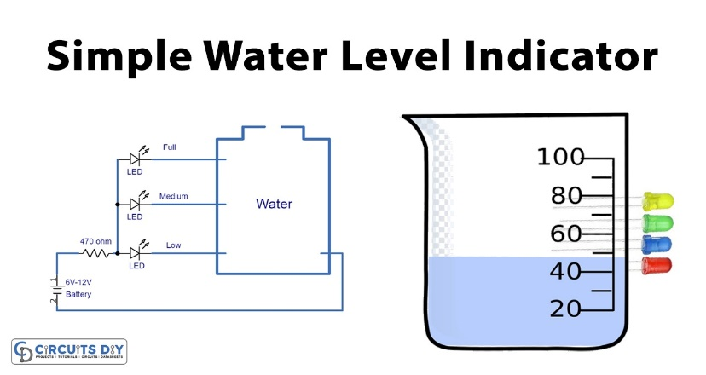

**Description of operation:**

* **Sensors (Float):** The sensors are placed at the desired water level points in the tank. When the water reaches these points, the sensors detect the presence of water.
* **Switch:** The switch is connected to the sensors and is triggered when the water reaches a specific level. This switch completes the circuit, turning on the rest of the components.
* **Buzzer:** Once the switch is triggered, indicating a specific water level, the buzzer is activated to sound an alarm, alerting the user to the water reaching that level.
* **Display Unit (LED Lights):** The display unit is activated along with the buzzer and shows the current water level. This can be in the form of LEDs lighting.
* **Power Supply:** The power supply provides the necessary power to the entire circuit, ensuring that the sensors, switch, buzzer, and display unit function correctly.

In operation, as the water level in the tank rises, the sensors detect the increasing water level. Once the water reaches a specific level, as indicated by the switch, the buzzer is activated. This setup provides a simple and effective way to monitor water levels and receive alerts at critical levels.

**Challenges Faced:**

During the project, several challenges were encountered, primarily related to sensor calibration. The float sensor initially struggled to provide accurate distance measurements, leading to inconsistent water level readings. This issue was addressed through thorough testing and calibration of the sensor, adjusting its settings to improve accuracy. Overall, these challenges were overcome through persistence, experimentation, and attention to detail, resulting in a fully functional water level indicator.

**Future Enhancements:**

To further improve the functionality and accuracy of the water level indicator, several enhancements can be considered:

* **Data logging:** Enable the device to record and store water level data for analysis.
* **Improved sensor technology:** Upgrade to laser or radar sensors for more accurate readings.
* **Smart home integration:** Integrate with smart home systems like Amazon Alexa or Google Home.
* **Automatic alert system:** Notify users of critical water levels, such as high or low levels.
* **Enhanced user interface:** Add a touchscreen display or graphical interface for easier interaction.
* **Energy efficiency:** Implement energy-saving features like sleep modes or low-power sensors.

**Conclusion:**

In conclusion, the water level indicator using sensors, a switch, a buzzer, a display unit, and a power supply provides a practical and efficient solution for monitoring water levels. This setup is versatile and can be used in various applications such as agriculture, industrial processes, and domestic water management. By alerting users to critical water levels, it helps prevent overflow or low water levels, ensuring efficient water usage and preventing damage to infrastructure. Overall, this apparatus offers a reliable and cost-effective way to monitor water levels and is a valuable tool for water management.

**References:**

<https://youtu.be/Hiqi1MHJg6Y?si=uDnJCCrRuGr5-T_a>

GitHub Link:

<https://github.com/01-134241-005/WATER-LEVEL-INDICATOR/>